Tutorial 10 – Automation & Regression Testing
Screenshot Report
Field | Details
Website / Tool | SauceDemo
URL | https://www.saucedemo.com
Module | Regression suite
Student Task | Execute the 6 regression test cases (after the Tutorial 5 baseline) and record Previous vs Current result.
Test Cases | Same TC IDs as the test case sheet: REG01 to REG06
Tester Name | Tester: Kothari Mann Jitendrakumar
Enrollment No | 2504030100433
Environment | Windows 10/11, Google Chrome (latest), internet connection

Test Case Execution

REG01 – Verify login (regression)
TC ID | REG01
Test Case | Verify login (regression)
Test Data | standard_user / secret_sauce
Expected Result | Products page opens
Actual Result | Products page opens
Status | PASS
Screenshot | 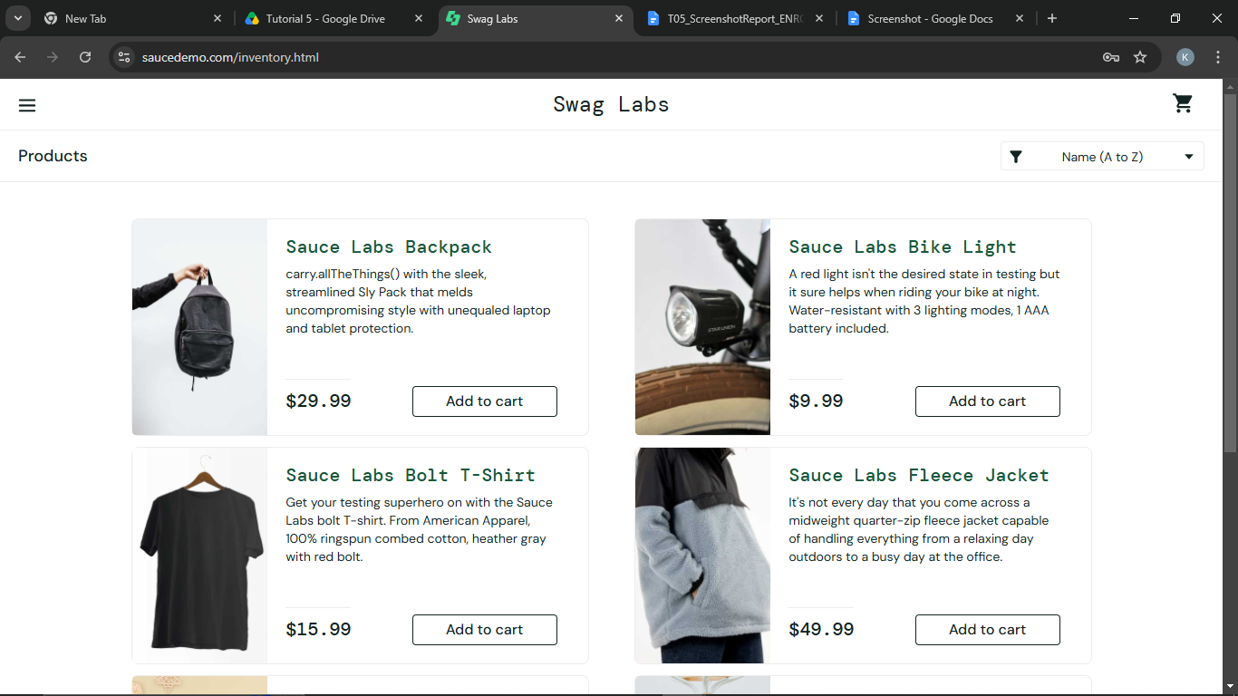
Defect ID | N/A

REG02 – Verify product display (regression)
TC ID | REG02
Test Case | Verify product display (regression)
Test Data | 6 products
Expected Result | Six products are displayed with image, name and price
Actual Result | Six products are displayed with image, name and price
Status | PASS
Screenshot | 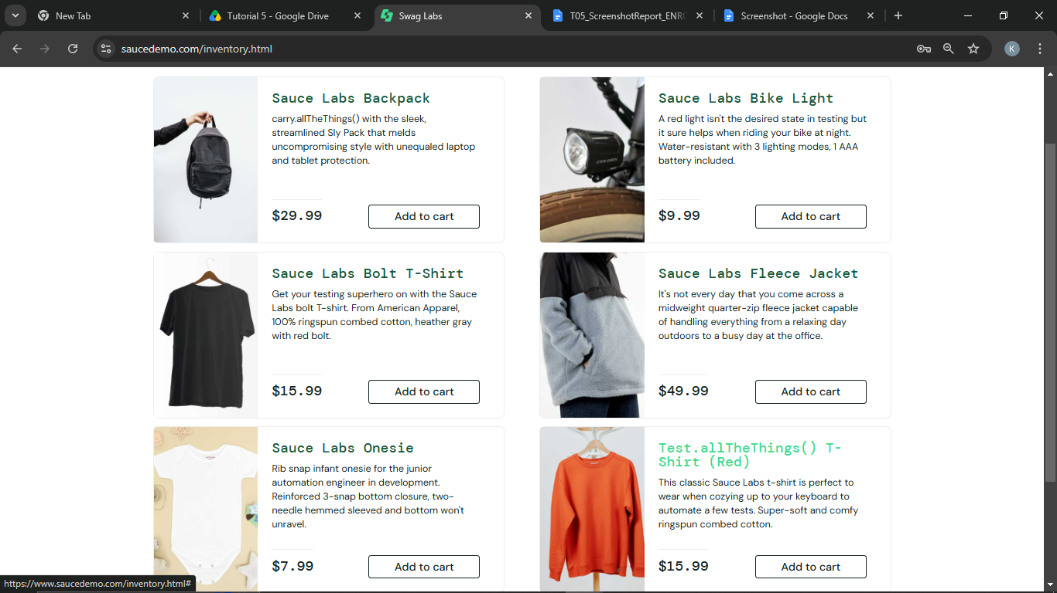
Defect ID | N/A

REG03 – Verify add to cart (regression)
TC ID | REG03
Test Case | Verify add to cart (regression)
Test Data | Sauce Labs Backpack
Expected Result | Cart badge shows 1
Actual Result | Cart badge shows 1
Status | PASS
Screenshot | 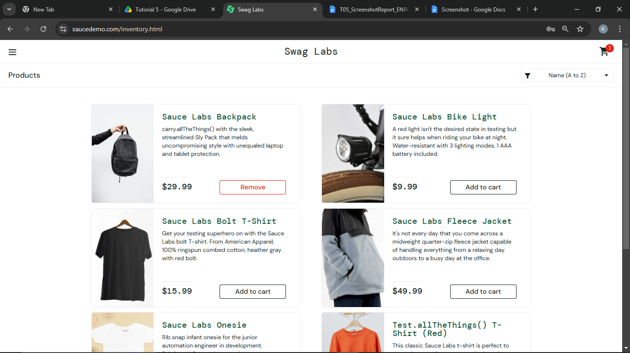
Defect ID | N/A

REG04 – Verify remove from cart (regression)
TC ID | REG04
Test Case | Verify remove from cart (regression)
Test Data | Sauce Labs Backpack
Expected Result | Cart badge disappears
Actual Result | Cart badge disappears
Status | PASS
Screenshot | 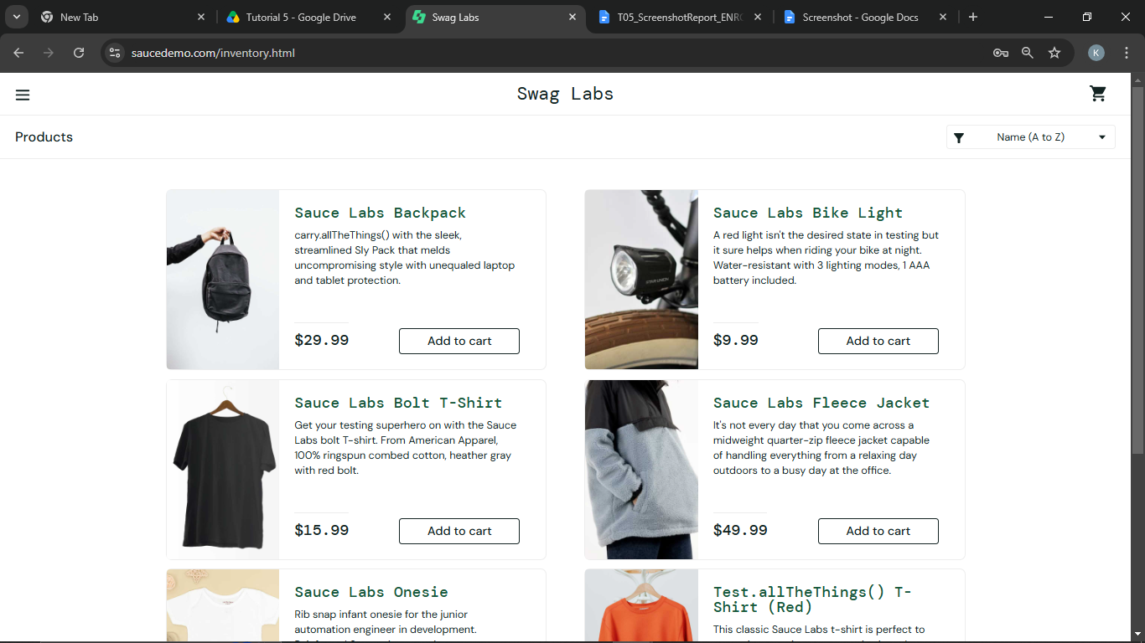
Defect ID | N/A

REG05 – Verify checkout (regression)
TC ID | REG05
Test Case | Verify checkout (regression)
Test Data | Test / User / 380001
Expected Result | 'Thank you for your order!' is displayed
Actual Result | 'Thank you for your order!' is displayed
Status | PASS
Screenshot | 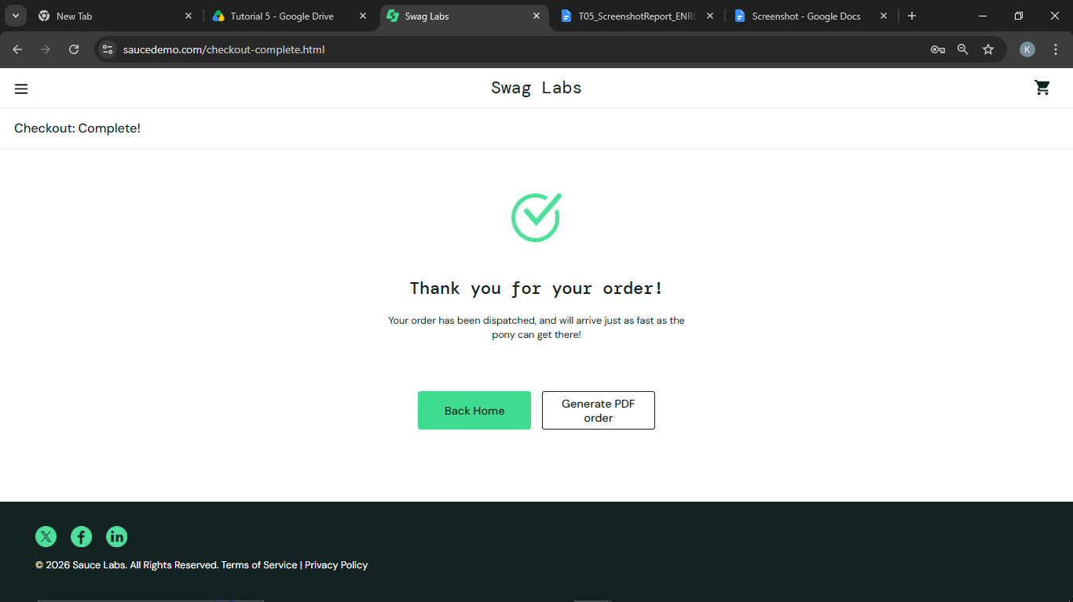
Defect ID | N/A

REG06 – Verify logout (regression)
TC ID | REG06
Test Case | Verify logout (regression)
Test Data | -
Expected Result | Login page is displayed
Actual Result | Login page is displayed
Status | PASS
Screenshot | 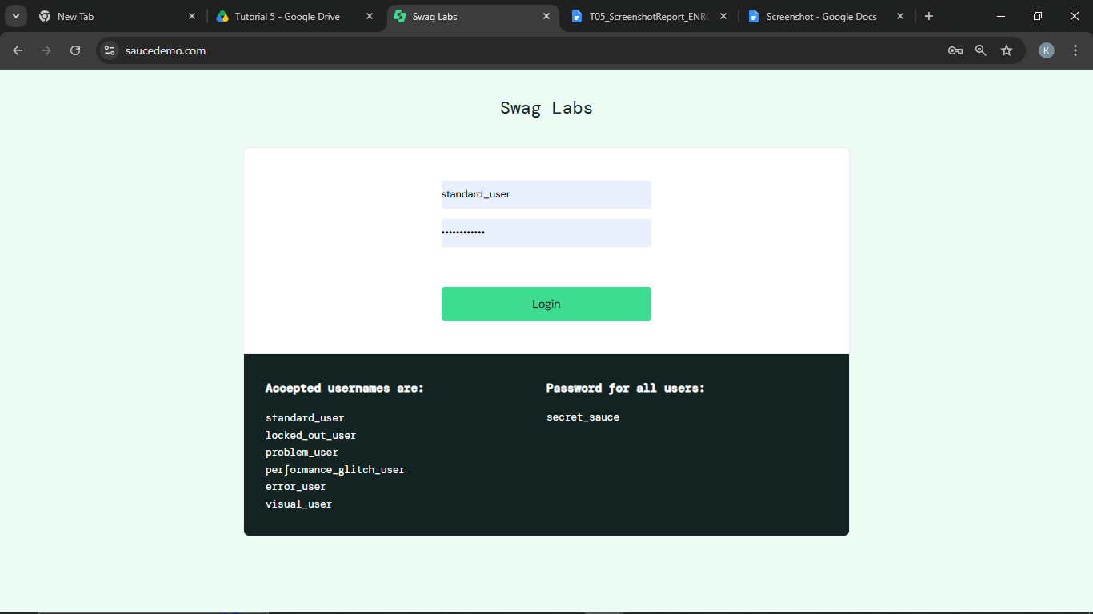
Defect ID | N/A

Regression Testing Result
TC ID | Previous Result | Current Result | Status
REG01 | Pass | Pass | Pass
REG02 | Pass | Pass | Pass
REG03 | Pass | Pass | Pass
REG04 | Pass | Pass | Pass
REG05 | Pass | Pass | Pass
REG06 | Pass | Pass | Pass

Module Analysis Table
Module Name | Functionality | Critical (Yes/No) | Frequently Changed (Yes/No) | Suitable for Automation (Yes/No) | Reason
Login | User authentication | Yes | No | Yes | Executed repeatedly and stable
Product display | Product list | Yes | No | Yes | Repeatable checks
Cart | Add / remove items | Yes | No | Yes | Repeated in every cycle
Checkout | Customer info and order | Yes | No | Yes | Stable multi-step flow
Logout | Sign out | No | No | Yes | Simple repetitive task
Visual layout | Look and feel | No | Yes | No | Needs human judgement

Automation Candidate Identification
Test Case ID | Functionality | Automation Recommended (Yes/No) | Reason | Automation Tool
REG01 | Login | Yes | Frequently executed | Selenium
REG02 | Product display | Yes | Repeatable | Selenium
REG03 | Add to cart | Yes | Stable | Selenium
REG05 | Checkout | Yes | Critical flow | Selenium
REG06 | Logout | Yes | Simple repetitive task | Selenium
UI-01 | Visual layout review | No | Needs human judgement | Manual Testing

Automation Feasibility Report
Criteria | Observation
Repetitive Test Cases | Yes
Stable Functionality | Yes
High Business Priority | Yes
Frequently Executed | Yes
Suitable Automation Tool | Selenium (Python)
Recommendation | Automate login, product display, cart, checkout and logout; keep visual checks manual

Regression Testing Summary
Metric | Value
Total Modules Analyzed | 6
Automation Candidates | 5
Regression Test Cases | 6
Modules Excluded | 1 (Visual layout)
Recommendation | Automate stable and repetitive modules; continue manual testing for frequently changing modules

Test Execution Summary
Metric | Value
Total Test Cases | 6
Passed | 6
Failed | 0
Blocked | 0
Not executed yet (fill after running) | 0
Pass % | 100.0%

